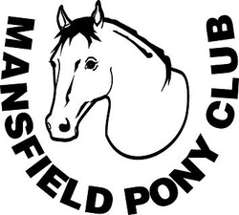
Mansfield Pony Club Inc
Uniform order form 2014

SURNAME
ADDRESS
P/CODE
EMAIL
PHONE

 | PRice | Size | QTY | Sub Total
Woolen Jumper size 6-14 | 75.00
Woolen Jumper Size 16-22 | 85.00
Rugby Top Kids 6-14 | 60.00
Rugby Tops Adult XXS-XXL | 60.00
Polo t-shirts | 45.00
Stadium Jacket | 80.00
Peak cap | 15.00
Pony Club badge | 12.00
Pony Club tie | 20.00
Saddle blanket -Large- | 66.00
Saddle blanket -small- | 50.00
Saddle blanket -cotton- | 45.00
Helmet cover blue/yellow | 30.00
Medical armband -leather | 33.00
Medical armband -plastic | 20.00
 |  |  | TOTAL

EFT PYMENTS TO MANSFIELD PONY CLUB INC BSB 633000 ACCOUNT 140751975 REFERENCE YOUR SURNAME OR INVOICE NUMBER.
POST COMPLETED FORMS WITH PAYMENT/EFT RECEIPT (DO NOT POST CASH) TO
MANSFIELD PONY CLUB, P.O.BOX 537 MANSFIELD VIC 3724
OR SEE THE TREASURER AT THE NEXT RALLY DAY.
CASH/CHEQUE/EFT
INVOICE NO#____________________
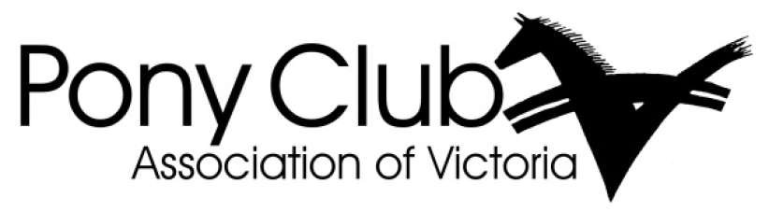

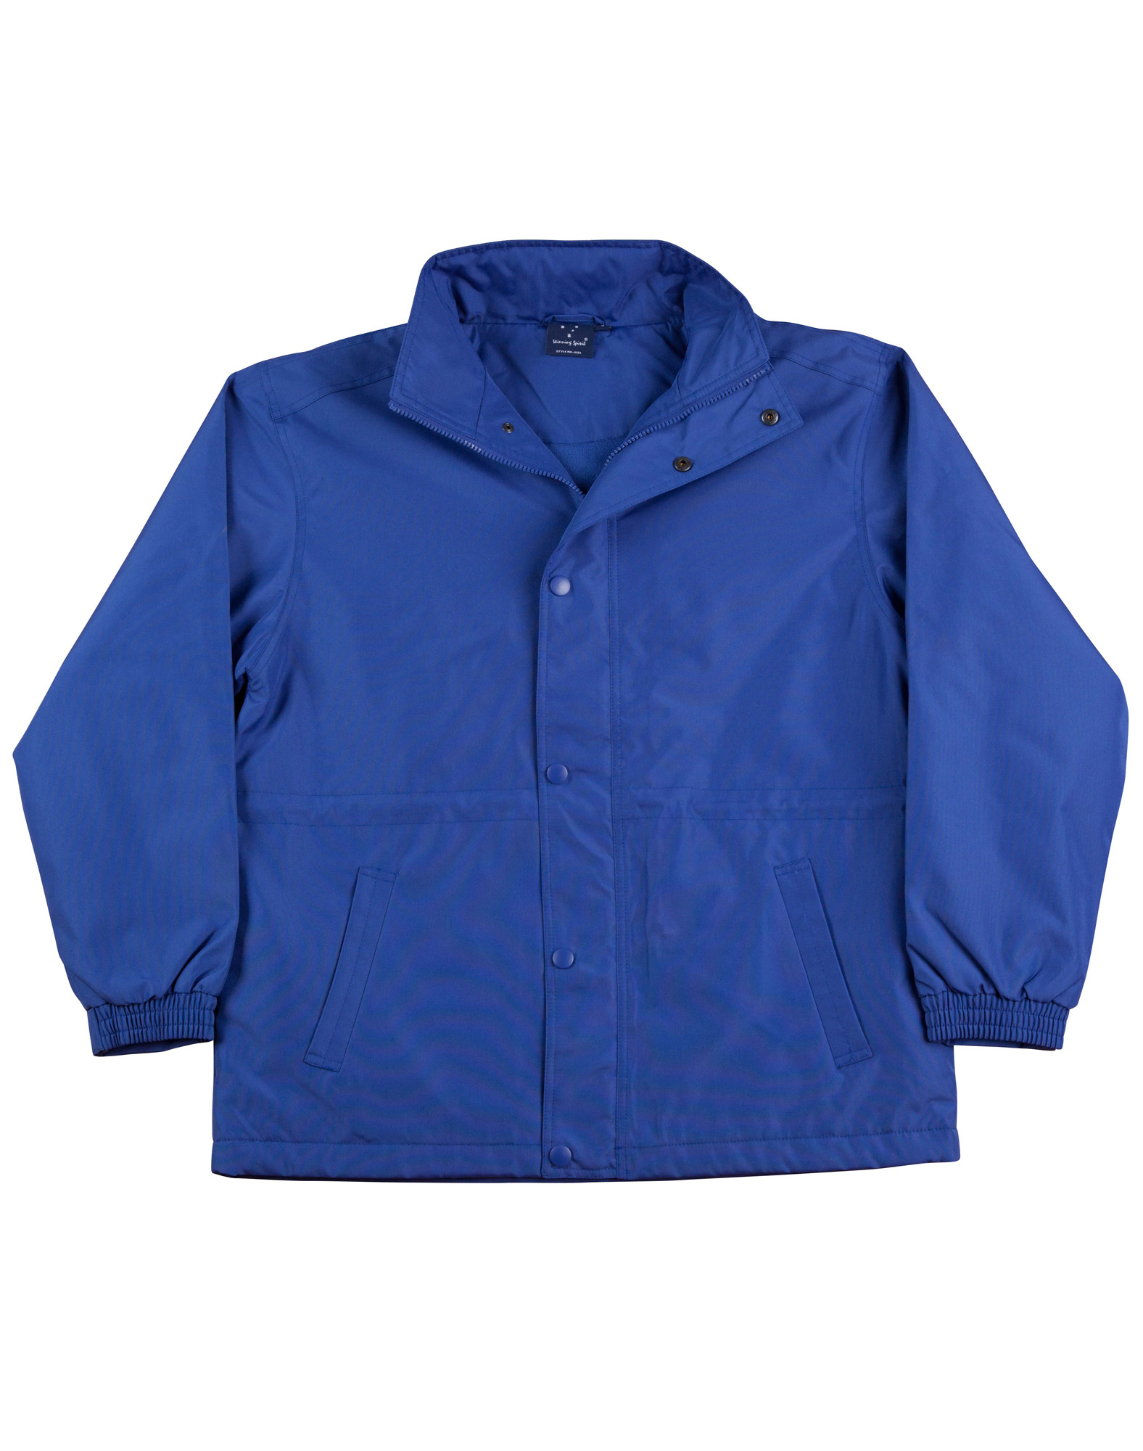

Stadium Jacket
Size Chart
Size | Half Chest | Length
Kids Size 8-10 | 49 cm | 60 cm
Kids size 10-12 | 52 cm | 65 cm
Kids size 12-14 | 55 cm | 70 cm
Adults XS | 58 cm | 72 cm
Adult S | 62 cm | 75 cm
Adult M | 65 cm | 78 cm
Adult L | 68 cm | 81 cm
Adult XL | 71 cm | 84 cm
Adult 2XL | 74 cm | 87 cm
Adult 3XL | 77 cm | 90 cm

